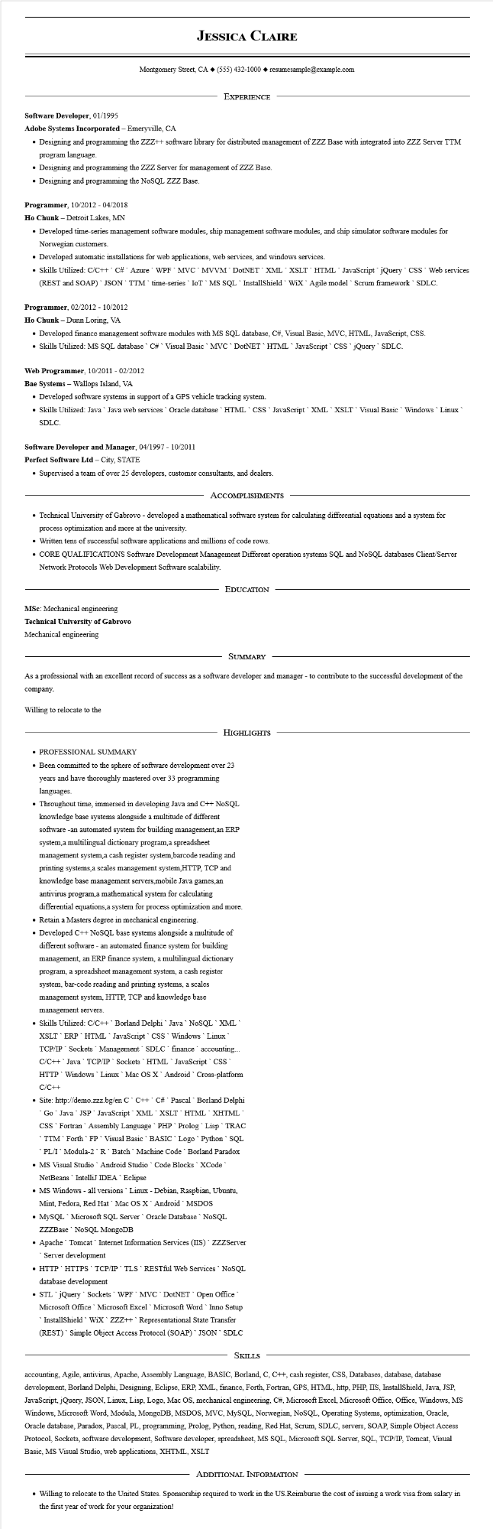
JESSICA CLAIRE
Montgomery Street, CA ◆ (555) 432-1000◆ resumesample@example.com
EXPERIENCE
Software Developer, 01/1995
Adobe Systems Incorporated - Emeryville, CA
• Designing and programming the ZZZ++ software library for distributed management of ZZZ Base with integrated into ZZZ Server TTM program language.
• Designing and programming the ZZZ Server for management of ZZZ Base.
• Designing and programming the NoSQL ZZZ Base.
Programmer, 10/2012 - 04/2018
Ho Chunk - Detroit Lakes, MN
• Developed time-series management software modules, ship management software modules, and ship simulator software modules for Norwegian customers.
• Developed automatic installations for web applications, web services, and windows services.
• Skills Utilized: C/C++ C# Azure WPF MVC MVVM DotNET XML XSLT HTML JavaScript jQuery CSS Web services (REST and SOAP)` JSON` TTM `time-series IoT MS SQL InstallShield` WiX Agile model Scrum framework SDLC.
Programmer, 02/2012 - 10/2012
Ho Chunk - Dunn Loring, VA
• Developed finance management software modules with MS SQL database, C#, Visual Basic, MVC, HTML, JavaScript, CSS.
• Skills Utilized: MS SQL database C# Visual Basic MVC DotNET HTML JavaScript CSS jQuery SDLC.
Web Programmer, 10/2011- 02/2012
Bae Systems - Wallops Island, VA
• Developed software systems in support of a GPS vehicle tracking system.
• Skills Utilized: Java Java web services Oracle database HTML CSS JavaScript XML XSLT Visual Basic Windows Linux SDLC.
Software Developer and Manager, 04/1997 - 10/2011
Perfect Software Ltd - City, STATE
• Supervised a team of over 25 developers, customer consultants, and dealers.
ACCOMPLISHMENTS
• Technical University of Gabrovo - developed a mathematical software system for calculating differential equations and a system for process optimization and more at the university.
• Written tens of successful software applications and millions of code rows.
• CORE QUALIFICATIONS Software Development Management Different operation systems SQL and NoSQL databases Client/Server Network Protocols Web Development Software scalability.
MSc: Mechanical engineering
Technical University of Gabrovo
Mechanical engineering
EDUCATION
SUMMARY
As a professional with an excellent record of success as a software developer and manager - to contribute to the successful development of the company.
Willing to relocate to the
HIGHLIGHTS
• PROFESSIONAL SUMMARY
• Been committed to the sphere of software development over 23 years and have thoroughly mastered over 33 programming languages.
• Throughout time, immersed in developing Java and C++ NoSQL knowledge base systems alongside a multitude of different software -an automated system for building management, an ERP system a multilingual dictionary program,a spreadsheet management system, a cash register system, barcode reading and printing systems, a scales management system, HTTP, TCP and knowledge base management servers,mobile Java games,an antivirus program, a mathematical system for calculating differential equations, a system for process optimization and more.
• Retain a Masters degree in mechanical engineering.
• Developed C++ NoSQL base systems alongside a multitude of different software - an automated finance system for building management, an ERP finance system, a multilingual dictionary program, a spreadsheet management system, a cash register
system, bar-code reading and printing systems, a scales management system, HTTP, TCP and knowledge base management servers.
• Skills Utilized: C/C++ Borland Delphi Java NoSQL XML XSLT ERP HTML JavaScript CSS Windows Linux TCP/IP Sockets Management SDLC finance` accounting... C/C++ Java TCP/IP Sockets HTML JavaScript CSS HTTP Windows Linux Mac OS X Android Cross-platform C/C++
• Site: http://demo.zzz.bg/en C C++ C# ` Pascal Borland Delphi Go Java JSP JavaScript XML XSLT HTML XHTML CSS Fortran Assembly Language PHP Prolog Lisp` TRAC TTM Forth FP Visual Basic BASIC Logo Python SQL PL/I Modula-2`R` Batch Machine Code Borland Paradox
• MS Visual Studio Android Studio Code Blocks XCode NetBeans IntelliJ IDEA Eclipse
• MS Windows - all versions Linux - Debian, Raspbian, Ubuntu,
Mint, Fedora, Red Hat Mac OS X Android MSDOS
• MySQL Microsoft SQL Server Oracle Database NoSQL ZZZBase NoSQL MongoDB
• Apache Tomcat Internet Information Services (IIS) ZZZServer Server development
• HTTP` HTTPS TCP/IP TLS RESTful Web Services NoSQL database development
• STL jQuery Sockets WPF MVC DotNET Open Office Microsoft Office Microsoft Excel Microsoft Word Inno Setup InstallShield WiX ZZZ++ Representational State Transfer (REST) Simple Object Access Protocol (SOAP)` JSON SDLC
SKILLS
accounting, Agile, antivirus, Apache, Assembly Language, BASIC, Borland, C, C++, cash register, CSS, Databases, database, database development, Borland Delphi, Designing, Eclipse, ERP, XML, finance, Forth, Fortran, GPS, HTML, http, PHP, IIS, InstallShield, Java, JSP, JavaScript, jQuery, JSON, Linux, Lisp, Logo, Mac OS, mechanical engineering, C#, Microsoft Excel, Microsoft Office, Office, Windows, MS Windows, Microsoft Word, Modula, MongoDB, MSDOS, MVC, MySQL, Norwegian, NoSQL, Operating Systems, optimization, Oracle, Oracle database, Paradox, Pascal, PL, programming, Prolog, Python, reading, Red Hat, Scrum, SDLC, servers, SOAP, Simple Object Access Protocol, Sockets, software development, Software developer, spreadsheet, MS SQL, Microsoft SQL Server, SQL, TCP/IP, Tomcat, Visual Basic, MS Visual Studio, web applications, XHTML, XSLT
ADDITIONAL INFORMATION
• Willing to relocate to the United States. Sponsorship required to work in the US. Reimburse the cost of issuing a work visa from salary in the first year of work for your organization!

